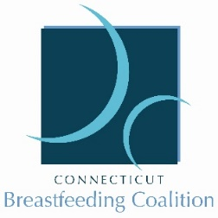
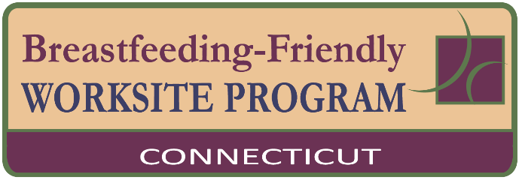

SAMPLE
Employee Lactation Support Policy

POLICY
To provide reasonable break time to nursing/lactating parents in order to chest/breastfeed their infant or express human milk.

PURPOSE
In recognition of the well-documented health advantages of human milk for infants and parents, and to comply with federal and state law, ___(employer name)_____ provides a supportive environment to enable chest/breastfeeding employees to either directly feed or express their milk during work hours.

Company Responsibilities
Employees who choose to continue providing their milk for their infants after returning to work shall receive:
- Milk Expression Breaks: Employees can use normal break and meal times for the purpose of chest/breastfeeding or to express milk (AKA pumping). For time that may be needed beyond the usual break times, employees may use personal leave, make up the time, or other reasonable accommodations as negotiated with their supervisor. The frequency and duration of breaks will likely vary, depending on the needs of the individual.
- A Place to Express Milk: A private space (not a bathroom) shall be available for employees to chest/breastfeeding or express milk. An employee Lactation Room is located ____________. Employees within the main building or at off-site locations who are not able to logistically utilize the Lactation Room may also chest/breastfeed or express milk in their own private office, or in other comfortable locations agreed upon in consultation with the employee’s supervisor. Any space designated or utilized for milk expression will be private and sanitary, located near a sink with running water for hand washing and rinsing pump parts, and have an electrical outlet.
- Milk Storage: Expressed milk can be stored in company refrigerators or in employee’s personal cooler.
- Equipment: For employee convenience, a double electric, hospital grade pump is located within the Lactation Room. Each employee must purchase their own “pump kit” to utilize this shared pump; employees may purchase a kit if they do not receive one while birthing, and may be eligible to receive a personal pump as well as lactation consultation at no cost or at a discounted rate through the group health plan.
- Education: Chest/breastfeeding education (before birth) and support through classes is available to employees. For more information employees may contact _(lactation consultant position)___.
- Support: Supervisors and managers are responsible for alerting employees to the company’s worksite lactation support program, prior to the employee taking leave to give birth, and for helping to facilitate each employee’s infant feeding goals. It is expected that all employees will assist in providing a positive atmosphere of support for lactating employees.
- List any other components specific to your worksite here.

-continued-

EMPLOYEE RESPONSIBILITIES
- Communication with Supervisors: Employees who wish to chest/breastfeeding or express milk during the work period shall keep supervisors and managers informed of their needs so that appropriate accommodations can be made to satisfy the needs of both the employee and the company. It is recommended that this be discussed prior to returning to work in order to have a plan in place, recognizing that needs will likely change over time.
- Maintenance of Milk Expression Areas: Employees utilizing the space are responsible for keeping milk expression areas clean, according to _____ (employer)___ cleaning policy. Employees are also responsible for keeping the general lactation room clean for the next user. This responsibility extends to both designated milk expression areas and other areas where milk may be expressed.
- Milk Storage: Employees should label all milk expressed with their name and date collected so it is not inadvertently confused with another employee’s milk. Each employee is responsible for proper storage of their milk using either a company refrigerator or in employee’s personal cooler.
- Use of Break Times to Express Milk: When more than one employee needs to use the designated lactation room, employees can use ______the sign-in log provided in the room/outlook calendar/slack channel/etc.____ to negotiate milk expression times that are most convenient or best meet their needs.

Additional policy support can be found via the Office of Women’s Health www.womenshealth.gov/supporting-nursing-moms-work
Inclusive language terminology and information can be found via National Association of County and City Health Officials & United States Breastfeeding Committee. (2021). Continuity of Care in Breastfeeding Support: A Blueprint for Communities. www.breastfeedingcontinuityofcare.org/blueprint; Appendix pg 71

